# Asteroids

TBD

Domain Model

**Table of Contents**

**Asteroids** **1**

**Figure 1: Game Subdomain Model** **3**

**Figure 2: Store Subdomain Model** **4**

**Figure 3: Net Subdomain Model** **5**

**Figure 4: Server Subdomain Model** **6**

**Figure 5: UI Subdomain Model** **7**

**Figure 6: Technical Services Subdomain Model** **8**

**Revision History**

|  |  |  |  |
| --- | --- | --- | --- |
| **Version** | **Date** | **Description** | **Author** |
| Elaboration Draft | 10/31/2018 | First Draft. | Eric Guzman |
| Elaboration 2 | 12/14/2018 | Updated the tech services domain model and the game domain model to reflect the new code | Eric Guzman |

# 

# **Figure 1: Game Subdomain Model**

This domain model shows the connections that are all related to the game package that is inside the domain layer.

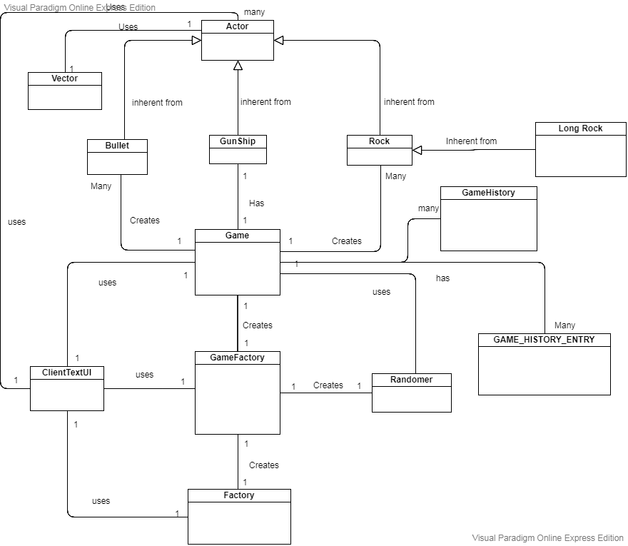

# **Figure 2: Store Subdomain Model**

This domain model shows the connections that are all related to the store package that is inside the domain layer.

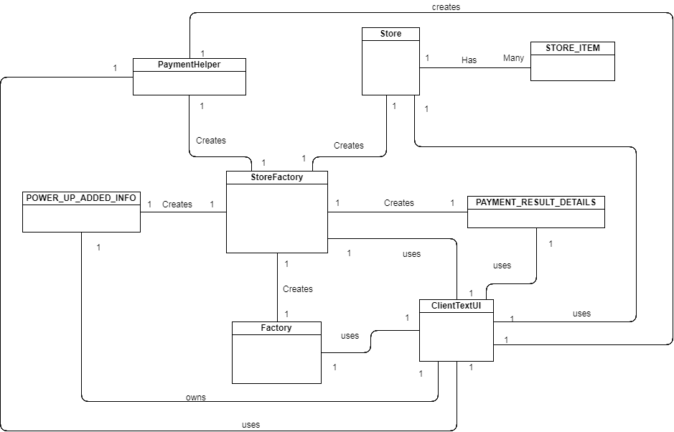

# **Figure 3: Net Subdomain Model**

This domain model shows the connections that are all related to the Net package that is inside the domain layer.

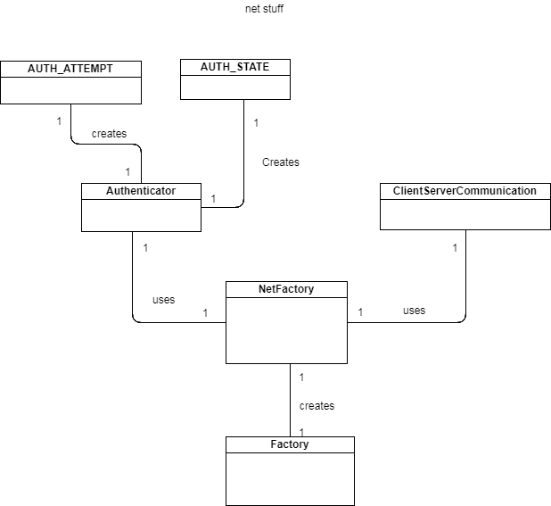

# **Figure 4: Server Subdomain Model**

This domain model shows the connections that are all related to the Server package that is inside the domain layer.

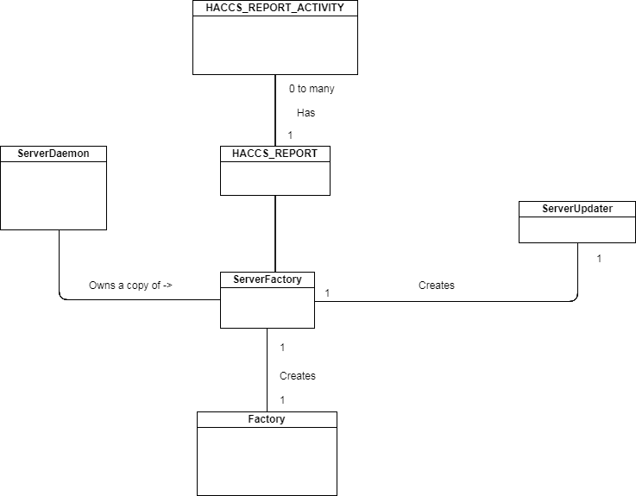

# **Figure 5: UI Subdomain Model**

This domain model shows the connections that are all related to the UI package that is inside the UI layer. .

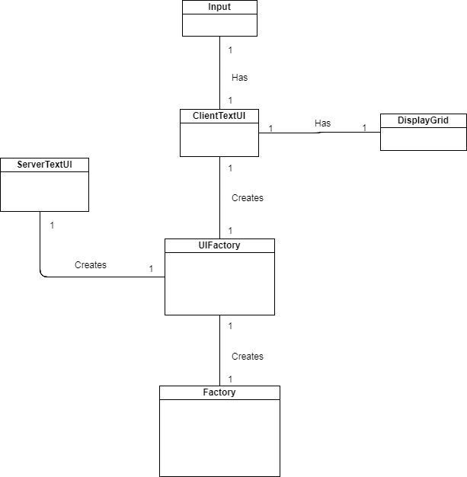

# **Figure 6: Technical Services Subdomain Model**

This domain model shows the connections that are all related to the technical services package that is inside the Technical Services layer.

